EE303B Fall 2017

**Report on Lab#4**

Dec. 16, 2017

Student No. 20160042

Koo InYong

Email: [iykoo010@kaist.ac.kr](mailto:iykoo010@kaist.ac.kr)

**Part I. Design and Simulation of modified traffic-light controller of Figure 17.10 and Figure 17.11 so that north-south and east-west have equal priority**

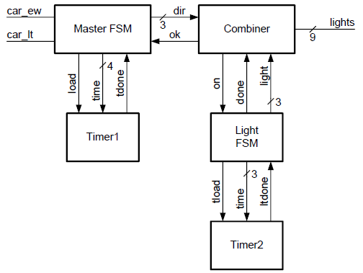 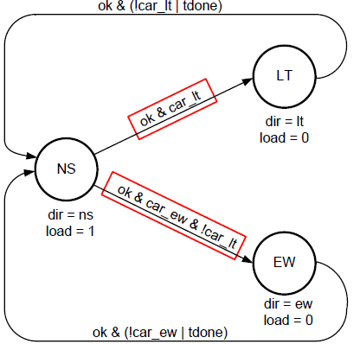

Figure 17.10 Block diagram of traffic-light controller Figure 17.11 State diagram of traffic-light controller

***GUIDELINE***

1. *Based on the modified block diagram and state diagram of the master FSM, modify the Verilog of the master FSM including module name changes:*

*-from TLC_Master to TLC_Master_v1*

*-from TB_TLC_Master_Combiner to TB_TLC_Master_Combiner_v1*

*And etc.*

1. *Compile the Verilog source codes, DUT(Device Under Test) and TB(TestBench)*
2. *Simulate the TB: Obtain the correct waveforms by confirming them with the original timing diagram*
3. *Evaluate the simulation results as a whole to check whether the traffic-light controller with the additional specification function according to the modified diagram for the master FSM*

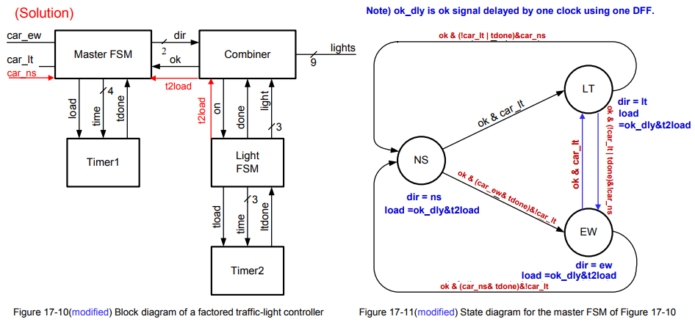

1. **Design (Verilog coding) of DUT (DUT: TLC_Master_v1.v)**

First, some predefined values are as following

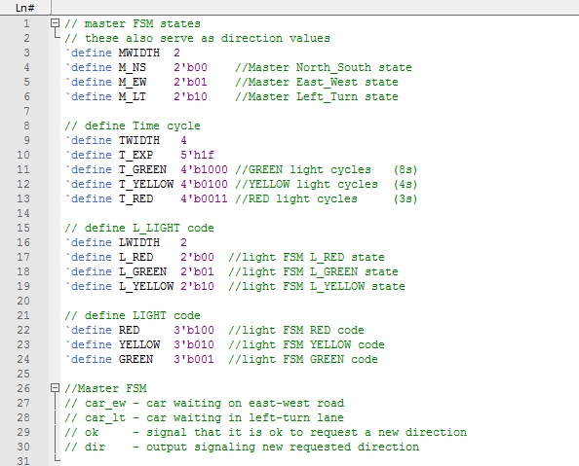

1-1 Definitions for TLC (Traffic Light Control)

Verilog code for module TLC_Master_v1 is as following.

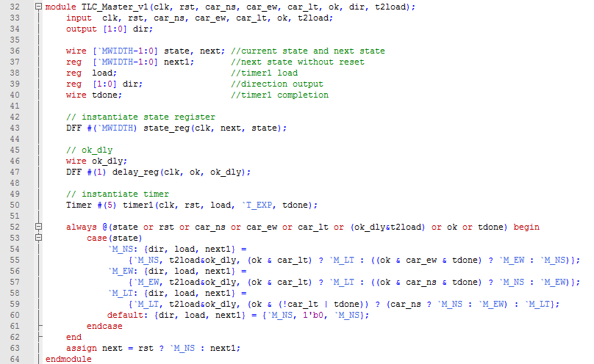

1- 2 Verilog coding of TLC_Master_v1 (modified master FSM for TLC)

The Verilog code for module TLC_Master (before modification) is as following.

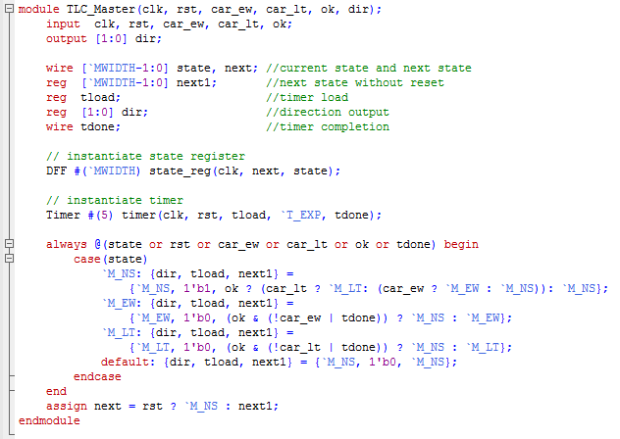

1- 3 Verilog coding of TLC_Master

We had to modify TLC_Combiner and TLC_Light module in order to transfer t2load to TLC_Master_v1.

The modified TLC_Combiner_v1 and TLC_Light_v1 modules are as following.

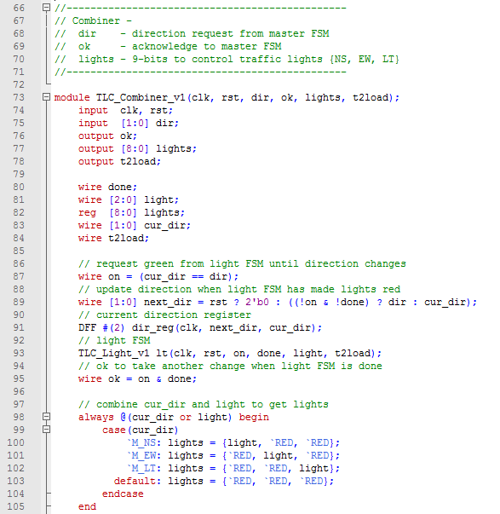

1- 4 Verilog coding of TLC_Combiner_v1

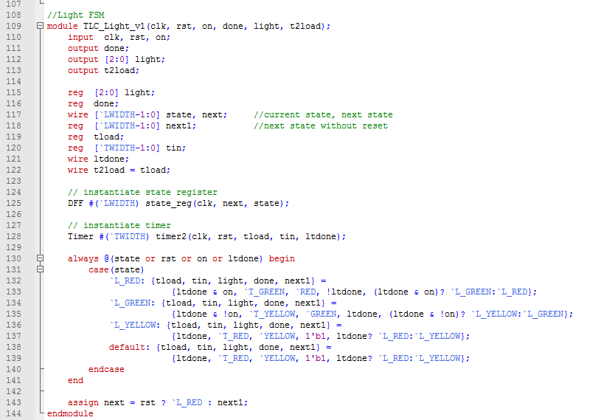

1- 5 Verilog coding of TLC_Light_v1

(We skip the original TLC_Combiner and TLC_Light module since the modifications are minor.)

1. **Simulation of the DUT by including the following clock generation and stimuli in the testbench (TB: TB_TLC_Master_Combiner_v1.v)**

The Testbench code was given on the pdf handout, and is as following.

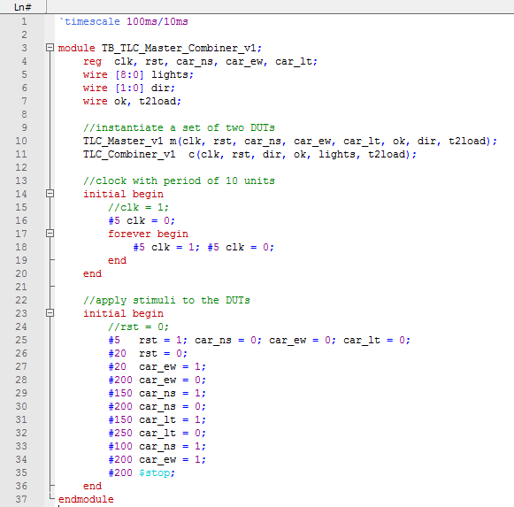

1- 6 Verilog coding of TB_TLC_Master_Combiner_v1

We modified the time interval of reset, from #10 to #20 (on code line 26), as we found error in initializing stage of the simulation as below.

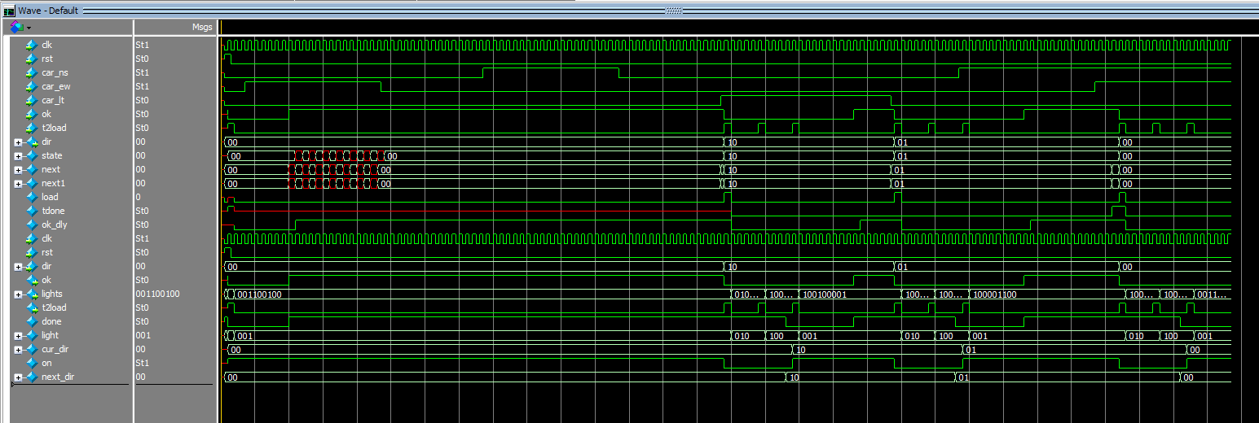

1- 7 Incorrect simulation result of modified TLC (Before modifying rst interval)

*tdone* (output of Timer 1) did not act normally, as we had uninitialized *load* value. *load* is determined as *t2load* & *ok_dly* value, where *ok_dly* is a one-clock cycle delayed value of *ok*. Which means, load can be determined after two clock cycles. Thus, we changed the reset interval, and the simulation worked normally.

This is the actual result of the simulation.

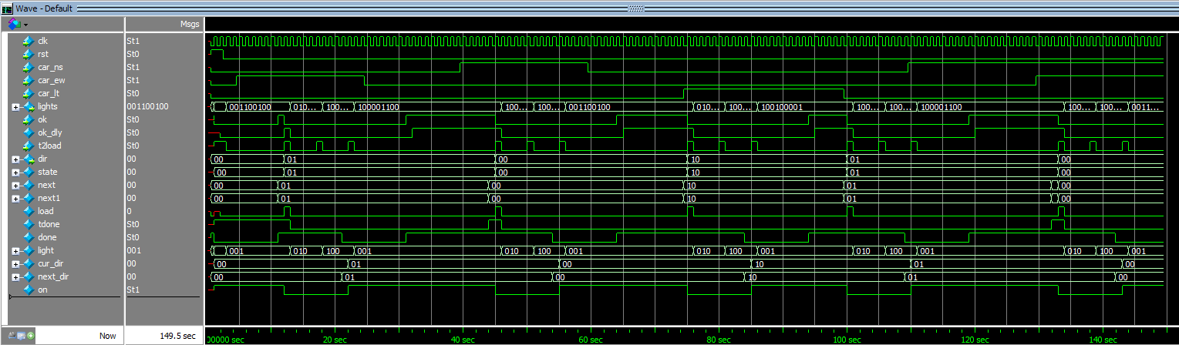

1- 8 Simulation result of modified TLC

1. **Evaluation**

We wanted to compare the result with the original timing diagram, using traffic-controller before modification.

Thus, we modified two lines in testbench as below.



1- 9 Code modification of Testbench for original timing diagram

The result showed as following.

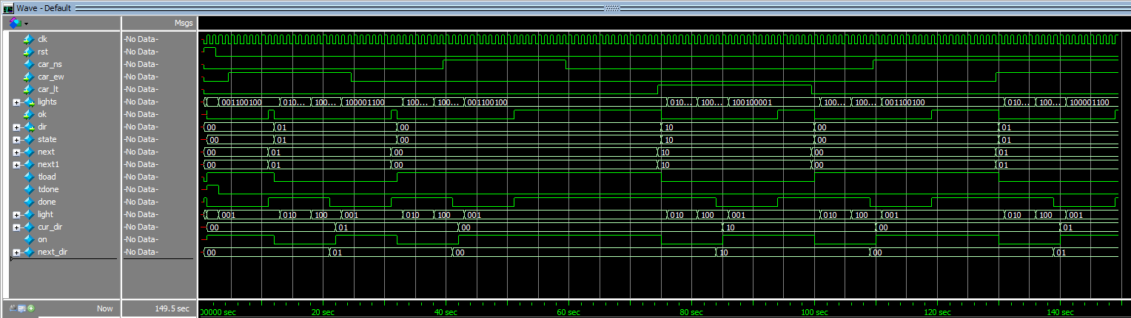

1- 10 Simulation result of original TLC

Let’s examine our results with detail.

I applied some description on Figure 1-8 and 1-10 as below.

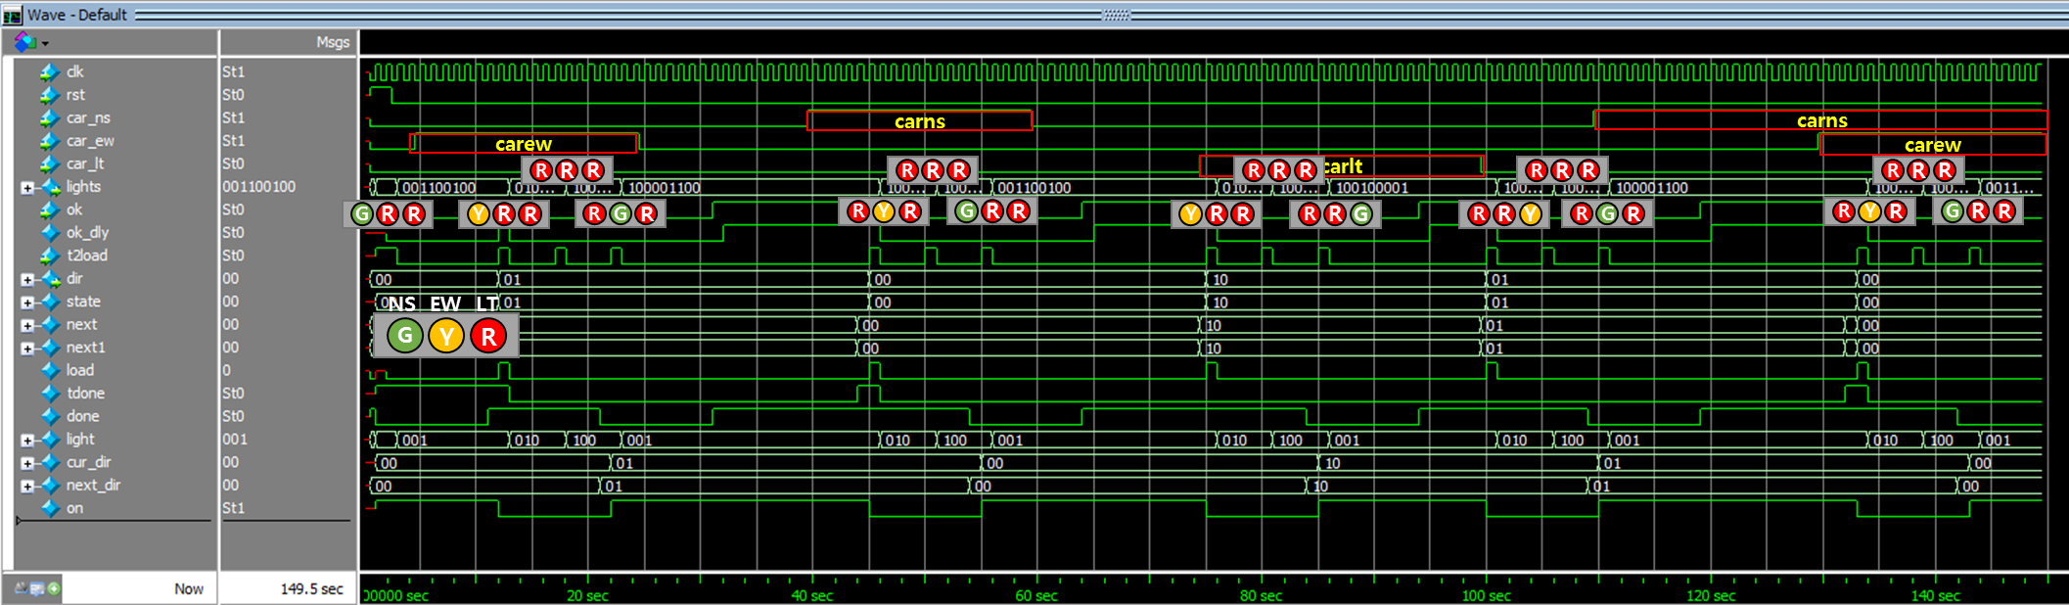

1- 8 (*detailed*) Simulation result of modified TLC

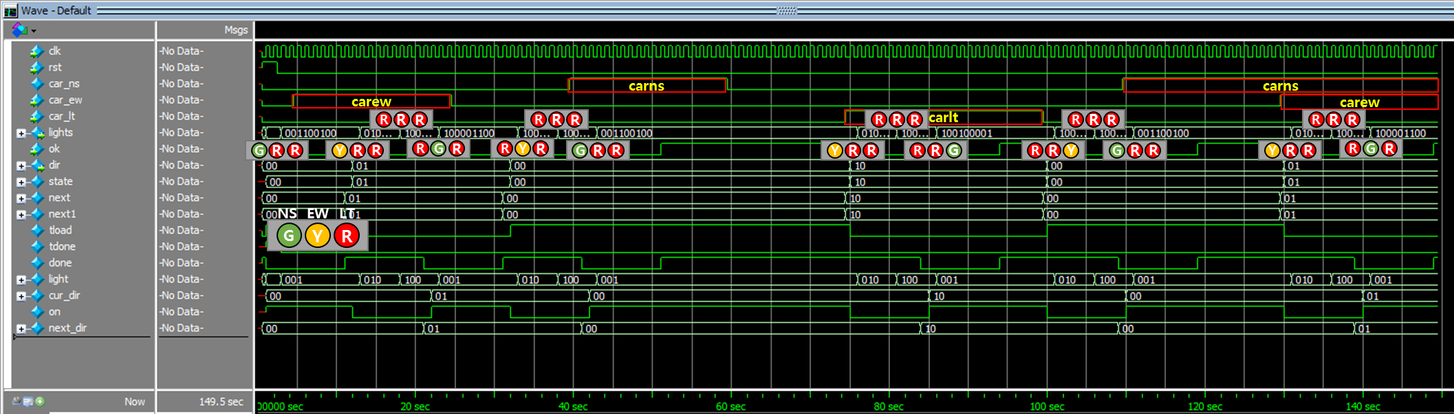

1- 10 (*detailed*) Simulation result of original TLC

In original TLC, car_ns input was not considered, so lights responded only on car_ew and car_lt. We can observe that lights returned to default state (*gns*) after some time interval as stimuli (car_ew or car_lt) are gone.

In modified TLC, we could see that lights returned to *gns* around 50 sec. (Original around 38 sec) The lights changed slower because now, *gns* is not the ‘default’ state, so lights remain on *gew* state until car_ns stimulus is applied.

Also note that around 110 sec, lights shift to *gew,* not *gns*, because according to state diagram of modified TLC, light goes to *gew* after car_lt stimulus is gone if there is no car_ns*.* Lights later respond to car_ns stimulus, and move to *gns* state though car_ew stimuli is also applied.

**Part II. Design and Simulation of Vending Machine FSM using Microcode**

1. **Design of the DUT**

Refer to Lab3 where we handled Vending Machine using pla.

We predefined some values as following.

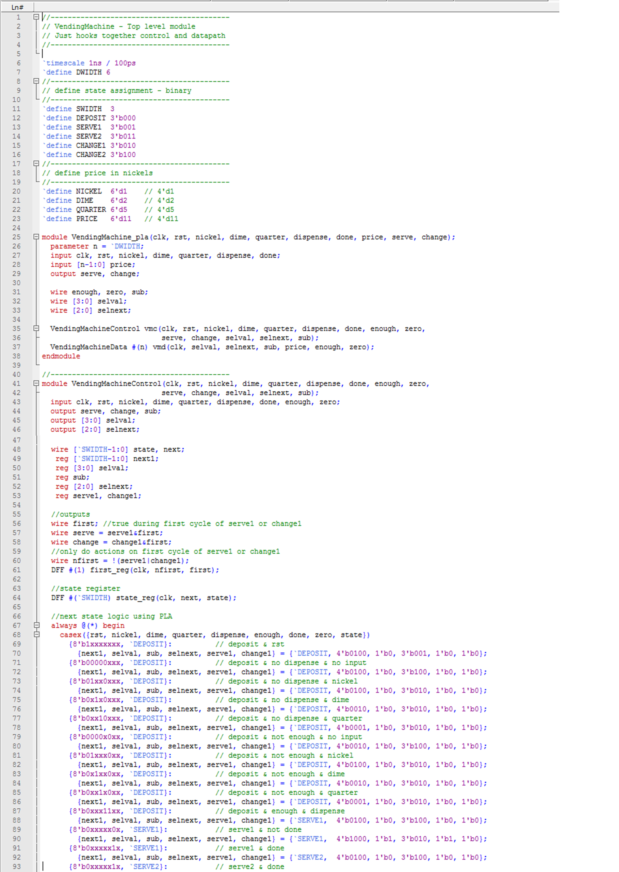

2- 1 Definitions for VendingMachine. (Reference to Lab3, VendingMachine_pla.v)

We will modify the some parts in VendingMachine_pla module, first from changing name to VendingMachine_ucode.

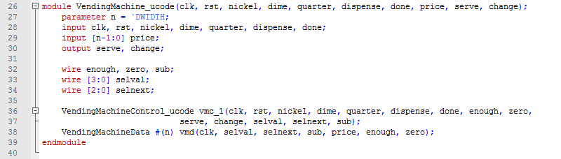

2- 2 Verilog Coding of VendingMachine_ucode

As you may see on code line 38, We will not modify VendingMachineData module.

Referring to Lab3, VendingMachineData and related modules are as following.

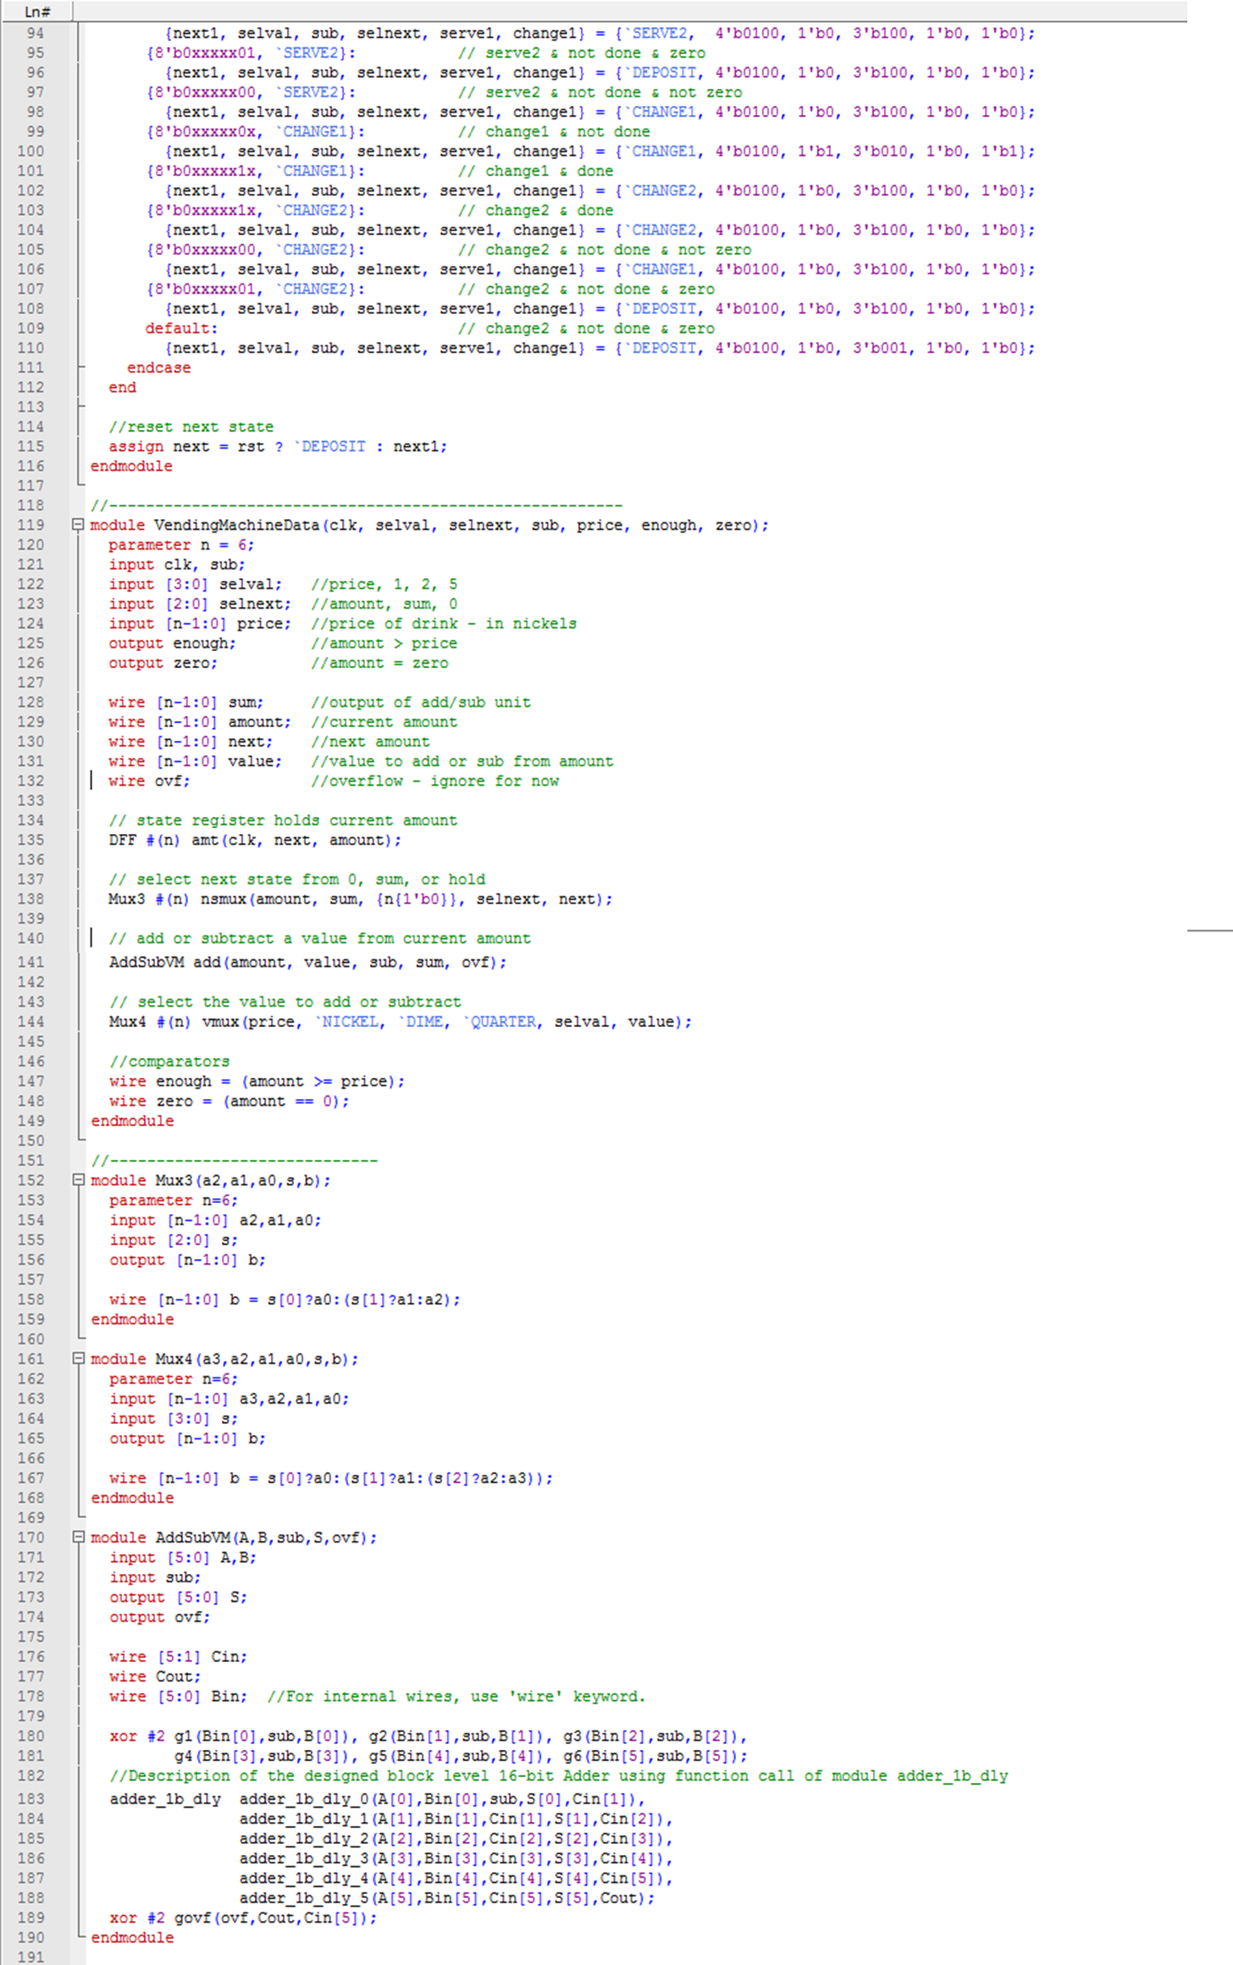

2- 3 Verilog Coding of VendingMachineData

Now, Verilog coding for VendingMachineControl_ucode is as following.

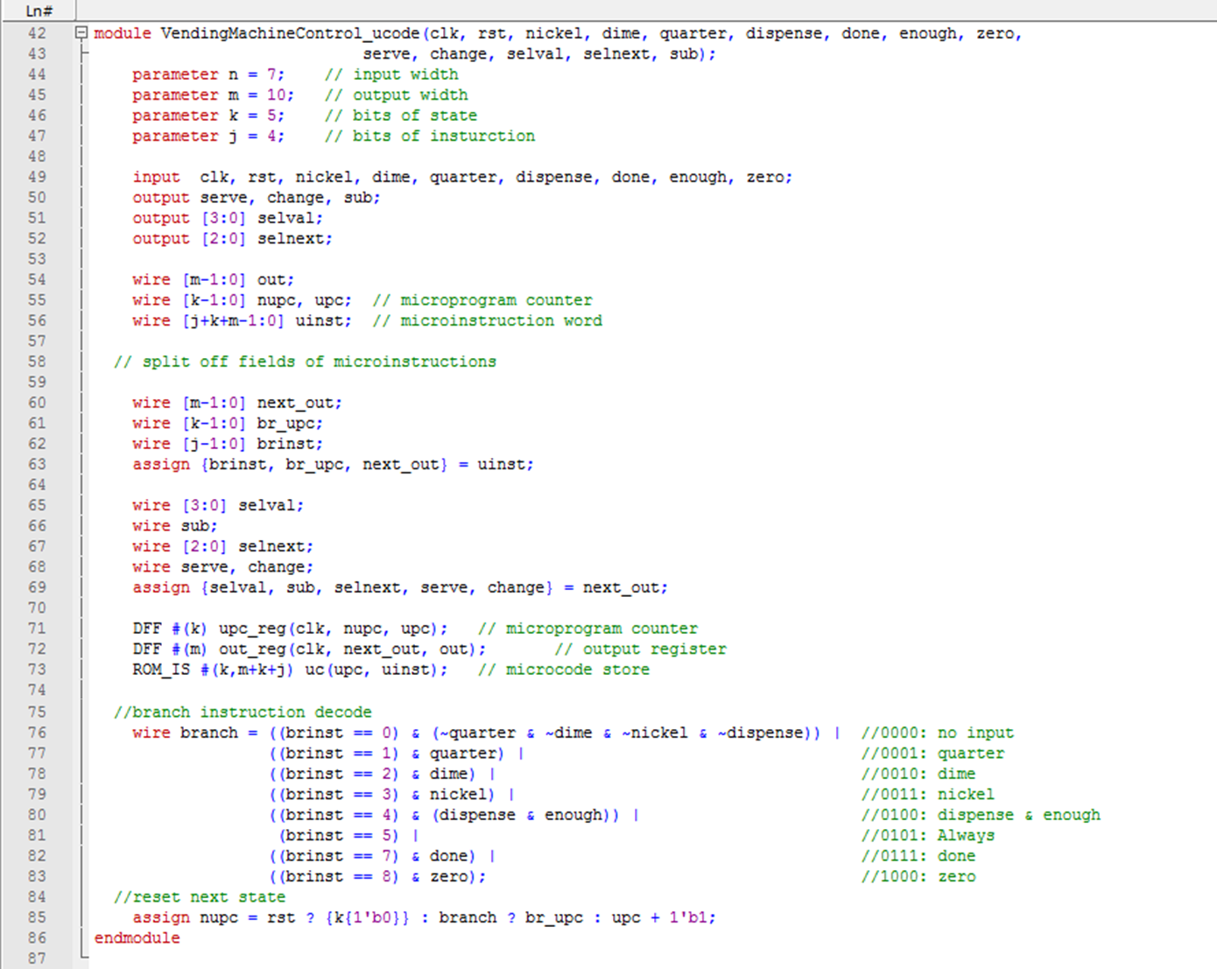

2- 4 Verilog Coding of VendingMachineControl_ucode

For ROM_IS, we used the Verilog code given in pdf handout.

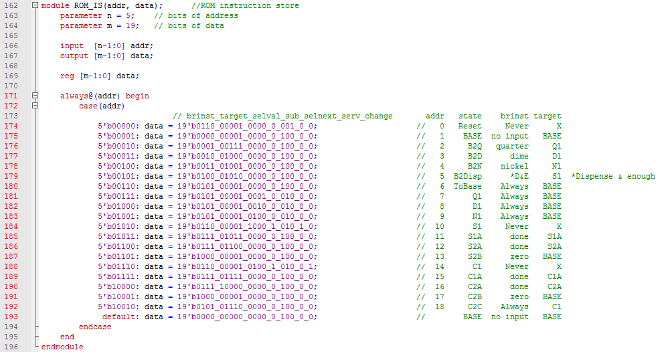

2- 5 Verilog Coding of ROM_IS

1. **Simulation of the DUT by including the following clock generation and stimuli in the testbench (TB: TB_TLC_Master_Combiner_v1.v)**

The Testbench code was given on the pdf handout, and is as following.

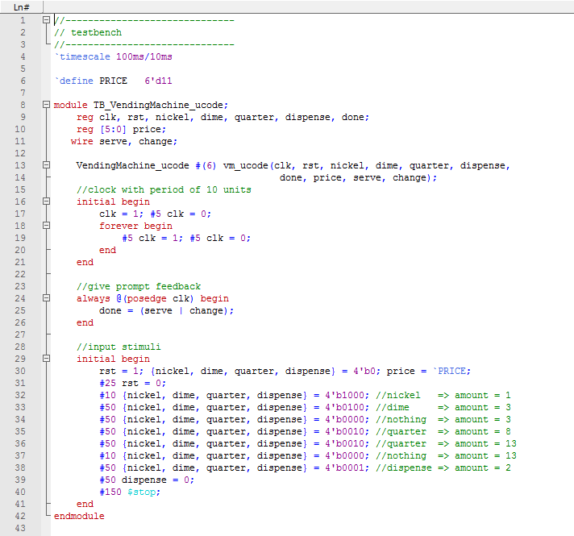

2- 6 Verilog coding of TB_VendingMachine_ucode

The Simulation result is as following.

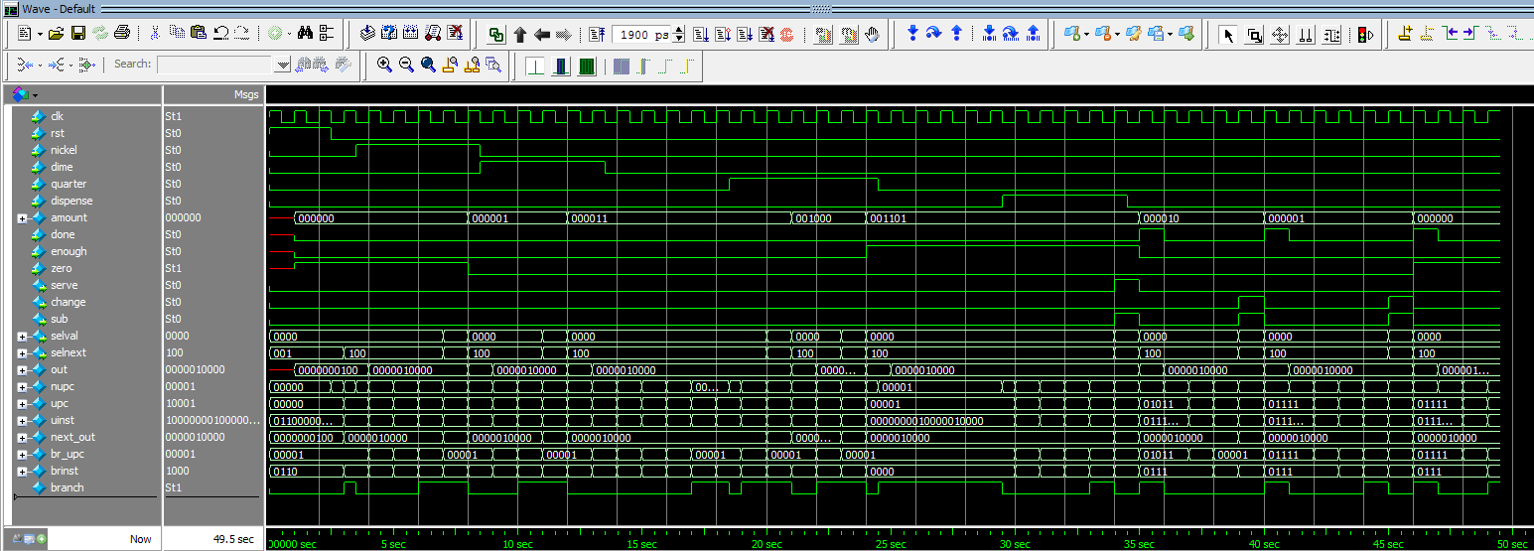

2- 7 Simulation result of VendingMachine_ucode

1. **Evaluation**

Recall evaluation of VendingMachine_pla_ovf, back in Lab3.

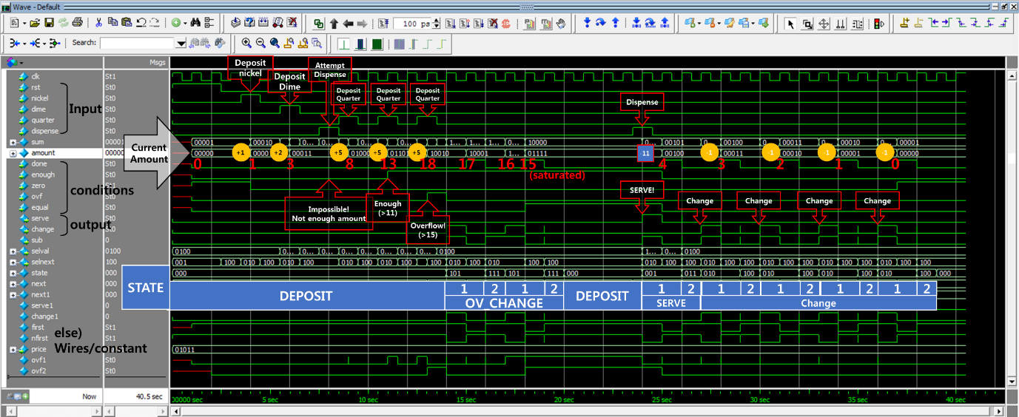

2- 8 Detailed evaluation on Simulation result of VendingMachine_pla_ovf

In similar principle, our result was examined with detail.

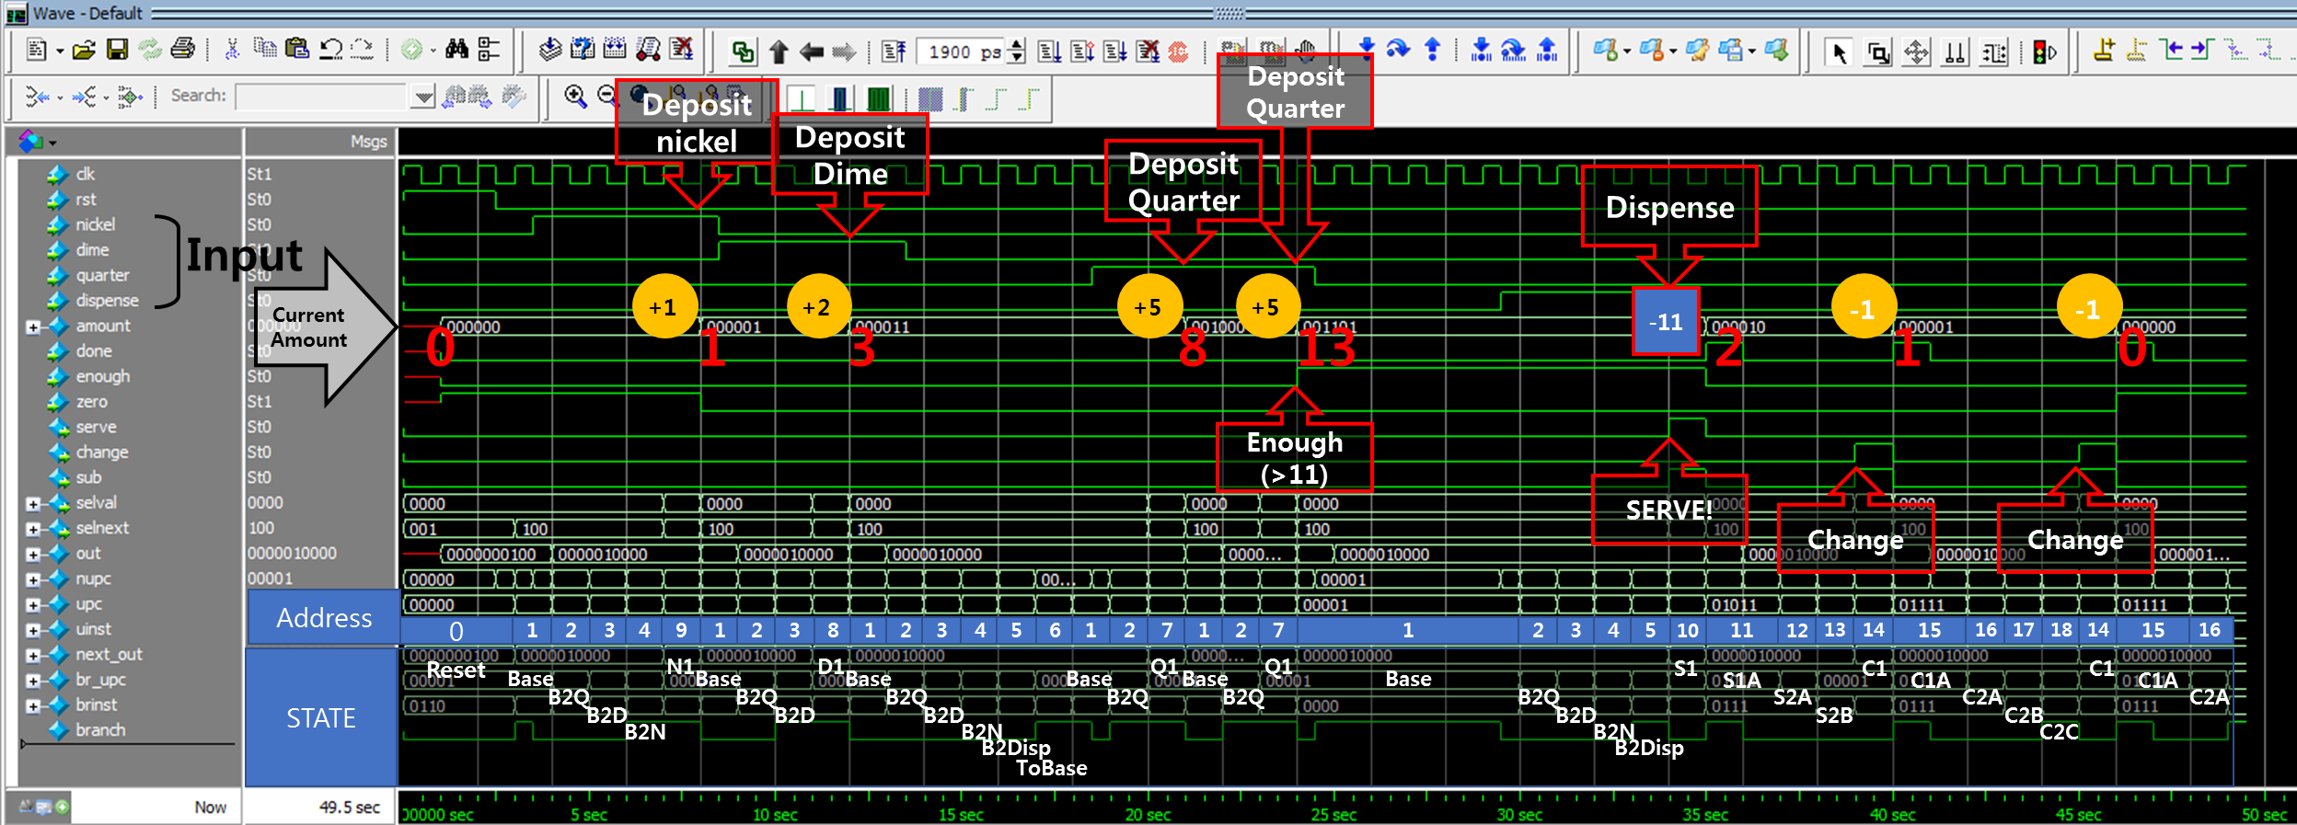

2- 9 Detailed evaluation on simulation result of VendingMachine_ucode

Following the *upc*, the *amount* and output of the system (*serve, change)* were observed.

Evaluation showed that our simulation is valid.

End of Report.

조교님, 교수님 감사합니다! ☺